The following notations are always **used between a cause and an effect**:

1. **Identity Function:** if c is 1, then e is 1. Else e is 0.

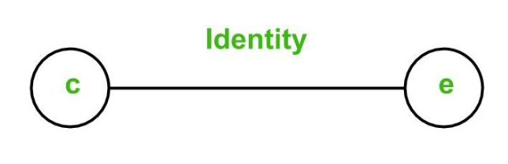

1. **NOT Function:** if c is 1, then e is 0. Else e is 1.

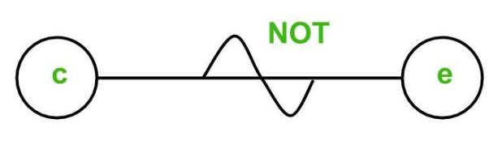

1. **OR Function:** if c1 or c2 or c3 is 1, then e is 1. Else e is 0.

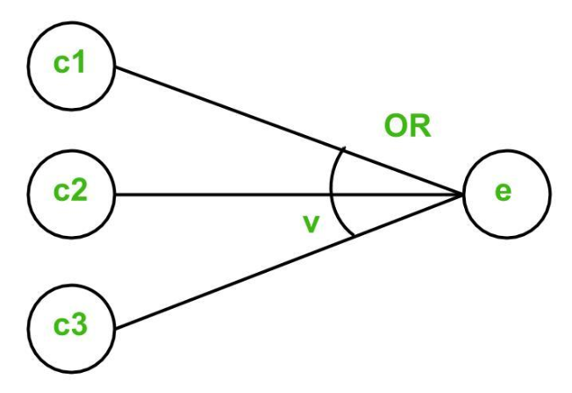

1. **AND Function:** if both c1 and c2 and c3 is 1, then e is 1. Else e is 0.

